* **Instapreneur Academy**

**How To Build A Massive Following And Reach Financial Independence Through Instagram Business?**

**Did you know the number one reason people don't make money online is not due to it's hard but because they don't have a following?**

**In fact, here's the biggest problem you face right now...**

**Most People Think That Building A Following On Instagram Is So Hard And Takes So Long That They Can't Imagine Becoming An Instagram Entrepreneur.**

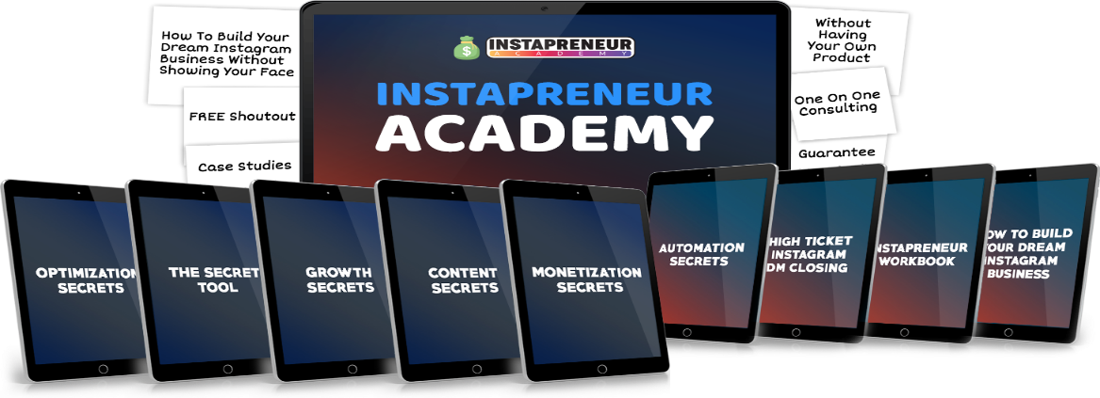

The Instapreneur Academy is an online program that teaches you exactly how you can build a massive following on Instagram and reach financial independence through Instagram business.

You'll learn my proven system I used to build over 2 million followers on Instagram.

This took me 10 months to create, 4 years of experience and it cost me a lot of my free time, but it was totally worth it.

The Instapreneur Academy makes building your own Instagram business so much easier!

You can start executing those strategies instantly which I developed with over 4 years of research and experience.

You'll get the secret strategies that are proven to work and I'll show you step-by-step how everything works

An Instapreneur is like an entrepreneur with a following on Instagram who sells products, services and advertisements on Instagram and positively impacts lives of their followers

JOIN now



Let Me Introduce You To The Instapreneur Academy and learn How To Grow Instagram And Build A Business On Instagram.

An Instapreneur is like an entrepreneur with a following on Instagram who sells products, services and advertisements on Instagram and positively impacts lives of their followers  
**Building a following on Instagram is really hard,** has to take a long time, or cost a ton of money because you’re stuck having to pay for promotions. Because if you try to make money online without building a following, it’s going to **be a LOT harder** for you to become successful!

Which means you might just struggle making money online… never share your message with the world… never live up to your full potential and when you die, your message dies with you.

Do you want to escape the system and NOT be a slave to it ?

**The secret to making money online is becoming an Instapreneur** because Instagram is the hottest social media platform with over 1 billion active users.

But luckily for you, there's now a solution...

**By the time you take action and say I want to escape the rat race and be financially free!**

You will  sell products, services and advertisements  like other **entrepreneurs on Instagram** .

You will be travelling the world, working on the beaches with your laptop or smartphone laptops and **making money doing what you love.**

**Click here to join**

**Here’s Everything You Get Today with Instapreneur Academy**

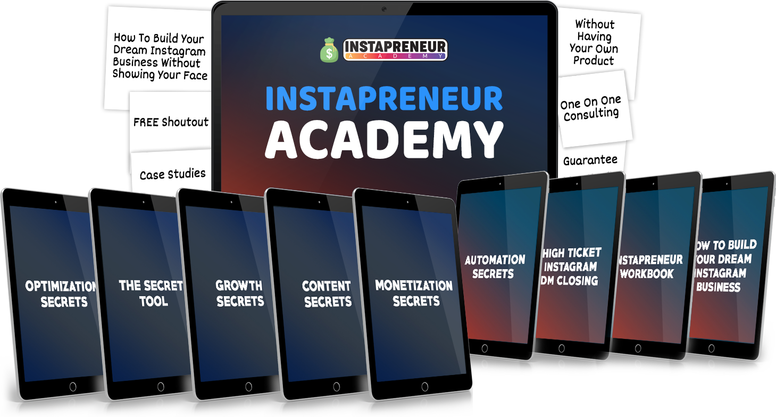

**An online course that teaches you exactly how you can build a massive following and reach financial independence through Instagram business**

**With the Instapreneur Academy you'll:**

* Learn the proven Instagram growth system so you can grow 500-1000 followers per day which means you'll never have to worry about not having enough followers
* ​Build a profitable Instagram business so you can reach financial independence which means you can fire your boss and break out of the 9-5 system
* Create content like the top 1% of influencers so you can get thousands of likes, comments, story views and followers which means you can make money doing what you love
* ​Grow your Instagram account 10x bigger than 99% of all instagrammers so you can reach millions of people which means you can change the world
* ​Know which hashtags to use so you can double your reach and gain thousands of new followers which means you won't have to struggle with Instagram growth again
* ​Learn how to completely automate your Instagram business so you can focus on the important things which means you can spend time with your friends and family and get time to do what you love
* ​And much, much more...

**Get Access now**



**Here's exactly what you're going to get with Instapreneur Academy when you get onboard today…**

Optimization Secrets

**($497 Value)**



I'll show you step-by-step how to optimize your Instagram account like the top 1% of Influencers. You'll learn:

* The secret Instagram Search Engine Optimization hacks
* ​How to find a profitable niche
* ​​How to build a brand
* ​​How Instagram algorithm works
* ​How to optimize visitors into followers and paying customers

The Secret Tool

**($97 Value)**

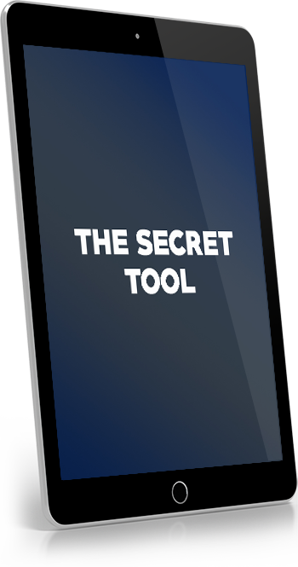

I'll reveal and give you a look inside the top content and hashtag research tool that the big Influencers use

Growth Secrets

**($1,997 Value)**



I'll reveal all my secret strategies that I used to build a following of over 2 million followers. You'll learn:

* How to hit the explore page
* ​How to go viral
* ​​How to gain thousands of followers with 1 single post
* ​The formula that will allow you to grow between 500-2000 followers per day!

Content Secrets

**($997 Value)**



The content secrets helps you to learn:

* How to create compelling content people love to Like, Comment, Save and Share with their friends.
* ​The art of Viral content
* ​​How to master the hashtag game
* ​How to write engaging captions
* ​How to get more story views

Monetization Secrets

**($4,997 Value)**



I'll reveal all my tips, tricks, hacks and strategies that you can use to build your dream Instagram business.

The monetization secrets helps you to learn:

* The exact strategy that I used to build a 6 figure Instagram business
* ​10 different strategies that you can use to make your first $10,000 with Instagram

VIP Support

**(Priceless)**



You will also get VIP support from me.

So, if you have any questions or need help with something then feel free to message me and I'll help you.

**PLUS, You’ll Also Get Immediate Access**

**To These TEN Insane Bonuses!**

**BONUS #1:**

Case Studies Of Successful Instapreneurs

**($97 Value)**

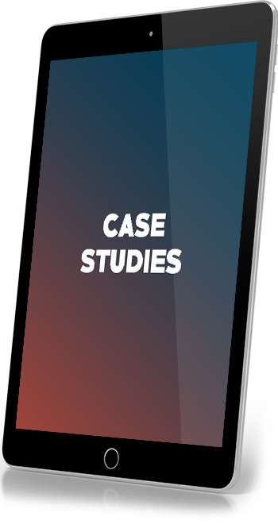

**BONUS #2:**

How To Build Your Dream Instagram Business Without Showing Your Face

**($197 Value)**



**BONUS #3:**

Automation Secrets

**($497 Value)**



**BONUS #4:**

The Dollars Without Followers Strategy

**($497 Value)**

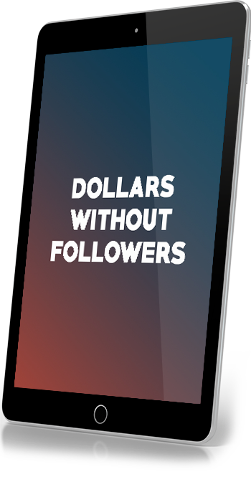

**BONUS #5:**

A FREE Shoutout On My 800,000 Followers Account (@mental.aspect)

**($97 Value)**



**BONUS #6:**

How To Build Your Dream Instagram Business Even Without Having Your Own Product

**($997 Value)**

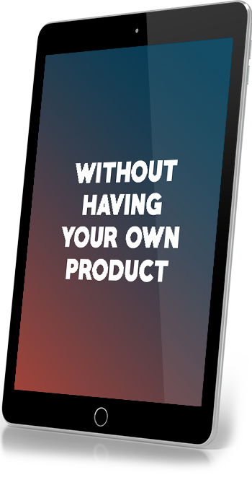

**BONUS #7:**

High Ticket Instagram DM Closing

**($997 Value)**



**BONUS #8:**

​Instapreneur Workbook

**($97 Value)**

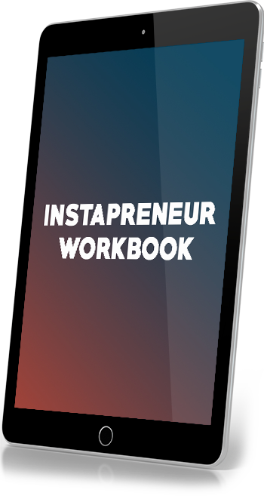

**BONUS #9:**

A 60 Day Money Back Guarantee

**($97 Value)**



**BONUS #10:**

Free Individual Consultation With Gurdit

**(Priceless)**



One more thing…

**I believe in the “Instapreneur Academy”**

**so much that I offer a…**

100% No-Questions-Asked

60 Day Money Back Guarantee